**GASABO DISTRICT COMPREHENSIVE ASSESSMENT**

**FOR 2ND TERM, ACADEMIC YEAR 2022-2023.**

**TRADES: ICT**

**RTQF LEVEL: 3**

**SUBJECT: WEBSITE DEVELOPMENT**

**DURATION: 3hrs 0n 13 / 03/ 2023 /**

**INSTRUCTION TO CANDIDATES:**

* This question paper consits of **THRE** sections **A, B and C**
* Answer all questions in section A **( 55marks).**
* Answer only **Three** questions in section B ( **30matks).**
* Answer only **One** question in sectio C ( **15marks**).
* Use only blue or black pen for answering.
* Mathematical instruments are allowed where it is necessary.

**Note:** Results for any candidate who is caught in examination malpractices are nullified.

**SECTION A: Attempt All questions (55marks)**

**___________________________________________________________________________**

1. **Copy and complete the following table**

|  |  |
| --- | --- |
| **Names of Short cut keys** | **Descriptions** |
| Ctrl + C **(0,5 marks)** |  |
| Ctrl + X **(0,5 marks)** |  |
| Windows key + L **(0,5 marks)** |  |
| Windows key + D **(0,5 marks)** |  |
| Windows key + D **(0,5 marks)** |  |
| Ctrl + N **(0,5 marks)** |  |
| Ctrl + P **(0,5 marks)** |  |
| Alt + Tab **(0,5 marks)** |  |
| Ctrl + Z **(0,5 marks)** |  |
| SHIFT+CTRL+9 **(0,5 marks)** |  |

1. Can a keyboard layout affect typing speed and accuracy? If so, which layout is considered the most efficient?
2. What do you make remember to the following notions

**/* text */**

**<!--text -->**

1. How do you clean a keyboard, and what should you avoid when doing so?
2. What is the role of Embed tag in html document
3. What are the different types of keyboard switches available, and what are the differences between them?
4. Which one of the following is **NOT** a valid HTML tag?

<BODY> b) <TEXT> c) <H2>

1. Which one of the following is in correct order of hierarchy (tags enclosing other tags)?
2. <BODY> , <TABLE>, <TR>, <TD>
3. <TABLE>, <TD>, <BODY>, <TR>
4. <TR>, <TABLE>, <TD>, <BODY>
5. Using examples distinguish ordered list from unordered list
6. What are the utility functions of the following tags and attributes:

<body></body>

<frameset></frameset>

<marquee></marquee>

Valign

Href

<hr>

1. What are at least 3 roles of form

**SECTION B: Attempt any Three (3) questions (30 marks)**

**___________________________________________________________________________**

1. Define the following terms and give the examples for each
2. Web site
3. www
4. Attribute
5. Tag
6. Browser
7. With examples explain multiple style sheets
8. State ten rules of Jacob Nielson for developing a web site
9. 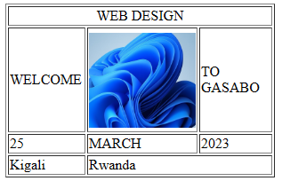Write a html code to produce the following out put :
10. Write HTML code to produce the following output

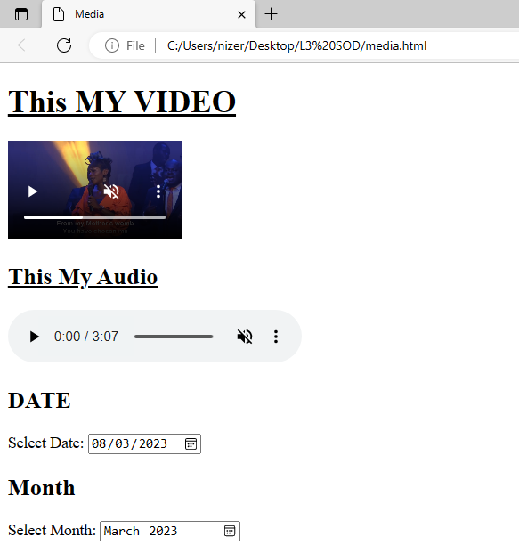

**SECTION C: Attempt only one (1) question (15 marks)**

**___________________________________________________________________________**

1. Talk about the application and differentiate the following tags with the examples

a) ID and Class

b) SPAN and DIV

1. Write the HTML codes to produce the following out put

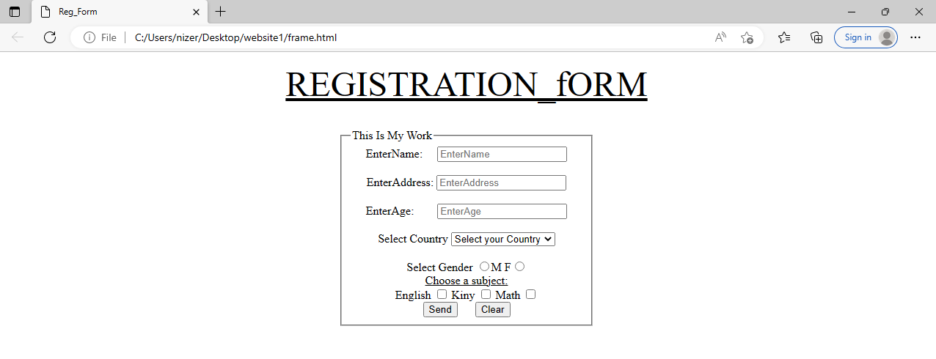

**END OF ASSESSMENT!**